

SCHOOL OF PSYCHOLOGY

118 College Drive #5025 | Hattiesburg, MS 39406-0001

Phone: 601.266.5411 | Fax: 601.266.5580 | mark.huff@usm.edu | www.usm.edu

March 4, 2021

The Graduate School

McCain Library

The University of Southern Mississippi

118 College Drive, #5024

Hattiesburg, MS 39406

To whom it may concern:

I am writing in support of Nicholas Maxwell’s application for the Graduate Competitive Travel Award. This award will provide Nick with travel support to present his work at a major conference and will greatly help with his educational development and growth as a graduate student.

The award will be utilized towards Nick’s attendance to the 62nd annual meeting of the Psychonomic Society which is being held this year in San Diego, CA on November 18th-21st. The Psychonomic conference is the major international conference for Cognitive Psychology and Judgment and Decision Making and currently has over 5,000 members and often attracts more than 2,500 researchers, students, and professionals who are engaged in the above areas ([www.psychonomic.org](http://www.psychonomic.org)). The Psychonomic conference is the flagship meeting for researchers in cognition and Nick has an excellent opportunity to join them in November. It is critically important for his educational development to be provided with additional exposure to the cutting-edge research and to build collaborative relationships that can assist him in networking with scholars at other institutions.

Nick is fully eligible for this award: He is currently a graduate student who is enrolled in our PhD program in Brain & Behavior and is in good academic standing. He began his studies in Fall 2018 and received this award previously 2 years ago. Nick has not yet submitted an abstract to the conference as the submission window is not yet open, but he has a completed project with data that are of appropriate quality for an international conference. The conference abstracts are typically accepted through the end of May and decisions made by September. I will be listed as a co-author on his submission and can confirm that he will attend this conference upon acceptance.

I will also note that the School of Psychology is prepared to provide matching funds for the conference up to $250 as required by the application.

If you have any questions about Nick’s conference submission or his application, please do not hesitate to contact me following my contact information below.

Sincerely,

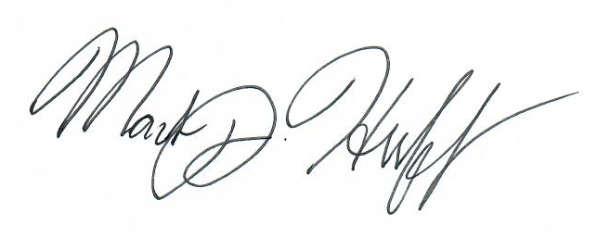

Mark J. Huff, PhD

Assistant Professor, Psychology

The University of Southern Mississippi

601.266.5411

mark.huff@usm.edu

I am planning to present my research at the 2022 Cognitive Aging Conference, which will be held April 7th-10th in Atlanta, GA. The primary goal of this conference is to foster collaboration and discussion of various areas of study related to both healthy and unhealthy aging (e.g., Alzheimer’s Disease) while providing a platform for sharing research. As such, this meeting provides an excellent platform to present research on aging and cognition across a variety of subfields within psychology, including cognitive psychology, neuroscience, and human factors psychology.

Participating in this conference is important to my professional development three reasons. First, this attending this conference provides me with an opportunity to present my research to a wide audience of experts in the field of cognitive aging. This is valuable experience, as it allows me to receive feedback on my work, generate ideas for future studies, and gives me exposure to new and emerging trends within the field of cognitive science. Second, this conference provides me with an excellent opportunity to make connections with other researchers in the field of aging, as it will provide me with ample opportunities for networking. Given that I am currently on the academic job market, these networking opportunities are critical for my growth as a researcher and my transition towards an academic career following graduation.

**Submitted Abstract:**

**Title:** Evaluating Switch Costs using Alternating-Runs and Random Sequencing in the Consonant-Vowel/Odd-Even Task in Younger, Healthy Older, and Mildly Impaired Older Adults

**Authors:** Jacob M. Namias, Nicholas P. Maxwell, & Mark J. Huff

**Abstract:**

The Consonant-Vowel/Odd-Even task (CVOE, Minear & Shah, 2008) is a task-switching paradigm that measures local and global task-switching costs. Participants are shown bivalent stimuli (e.g., A-18) and are asked to classify the letter (consonant/vowel) or the number (odd/even). Global switch costs (i.e., error rates and latencies for switch vs. pure trials) have been shown to increase as a function of both age and cognitive impairment. Older adults, however, have shown reduced local switch costs (i.e., switch vs. non-switch trials within switch blocks) for RTs relative to younger adults, suggesting that they are less tuned to the task (Huff, Balota, Minear, Aschenbrenner, & Duchek, 2015). Prior work has investigated switch costs using an alternating-runs sequencing in which task switching is predictive (i.e., CV-CV-OE-OE-CV-CV, etc.). The present study compares alternating-runs to a separate block in which switching occurs unpredictably (i.e., random CV/OE trials). Older adults again showed greater RTs versus younger adults across all trial types. Further, older adults showed increased global switch costs for both sequences, but local switch costs were only greater for the random sequence. RT distributions were further investigated. Regarding error rates, younger and older adults showed similar errors, but errors were greater for mild cognitively impaired (MCI) older adults. Our findings suggest that task-set reconfiguration processes associated with local switch costs are particularly taxed for older adults when switching is nonpredictive, and this pattern is exaggerated for those with mild cognitive impairment.

**Estimated Budget:**

I am expecting a round trip flight from Gulfport to Atlanta to cost approximately $230.

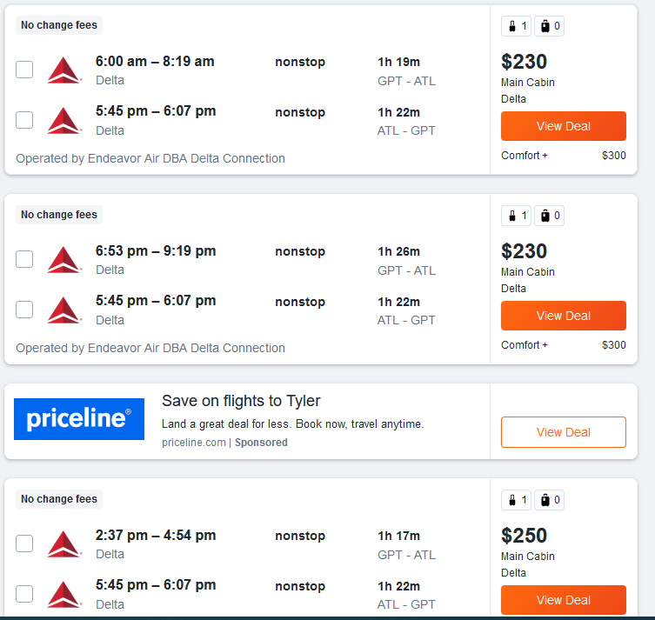

The conference has reserved a block of rooms at the JW Marriot hotel in Atlanta, Georgia. Since I’ll be travelling with 2 other individuals, a room for three individuals for three nights is expected to cost $522 before taxes. Since this would be split three ways, my share would be approximately $174.

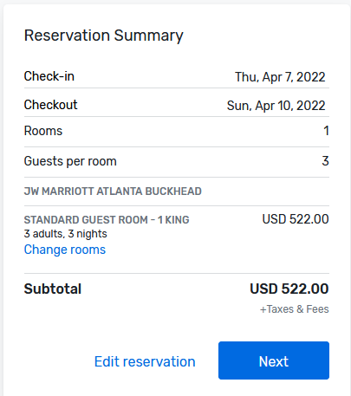

Finally, the conference has a $50 registration fee for students.



Thus, I am anticipating that the cost of this trip will be approximately $500 for the registration fee, transportation, and lodging.